APPENDIX 10: LOCAL GREEN SPACES AND OPEN SPACE & RECREATION SITES LIST AND DETAILED MAPS





December 2024
Local Green Space Sites
Key to sites on maps

- Allotment adjacent to Rifle Club, Barn Lane
- Bedford Bolitho Gardens
- Bleu Bridge Allotments
- Bolitho Gardens
- Boscathnoe Reservoir
- Bowjey
- Burial Ground, Rock Terrace
- Cholera Field (Burial Ground)
- Coastal Strip adjacent to Sandy Cove
- Crankan Allotments
- Freshbrook Close Green Space (north)
- Freshbrook Close Green Space (south)
- Greenspace between A30 and Railway Line
- Greenspace between B3311 and Railway Line
- Gulval Carn
- Gulval Churchyard
- Gulval South Churchyard
- Heamoor Old School Field
- Jack Stephens Estate Amenity Space (East)
- Jack Stephens Estate Amenity Space (West)
- Keel Alley Green Space
- Lariggan Allotments
- Lariggan Copse
- Lariggan Gardens
- Lescudjack Allotments
- Lescudjack Amenity Space
- Leskinnick Allotments
- Love Lane Allotments
- Love Lane Open Space
- Mann’s Field
- Millennium Woods
- Morrab Gardens
- Mount Misery Allotments
- Mount Misery (Bluebell Dell)
- Mount’s Bay Road Allotments
- Newlyn Green
- Parc Letta Green
- Paul Churchyard
- Paul New Churchyard
- Pendarves Flats Amenity Space
- Pendennis Road Amenity Space
- Penlee Park
- Penlee Point Allotments
- Penrose Gardens
- Penzance Cemetery
- Penzance Jewish Cemetery
- Poltair Woods
- Princess Royal Gardens
- Quillet Road Amenity Space
- Rosebud Gardens
- Sheffield Road Cemetery
- St Anthony’s Gardens
- St Clare Flats Amenity Space
- St Mary’s Churchyard
- The Close Green Space
- Trannack Allotments
- Tredavoe Village Green
- Trenoweth Crescent Amenity Space

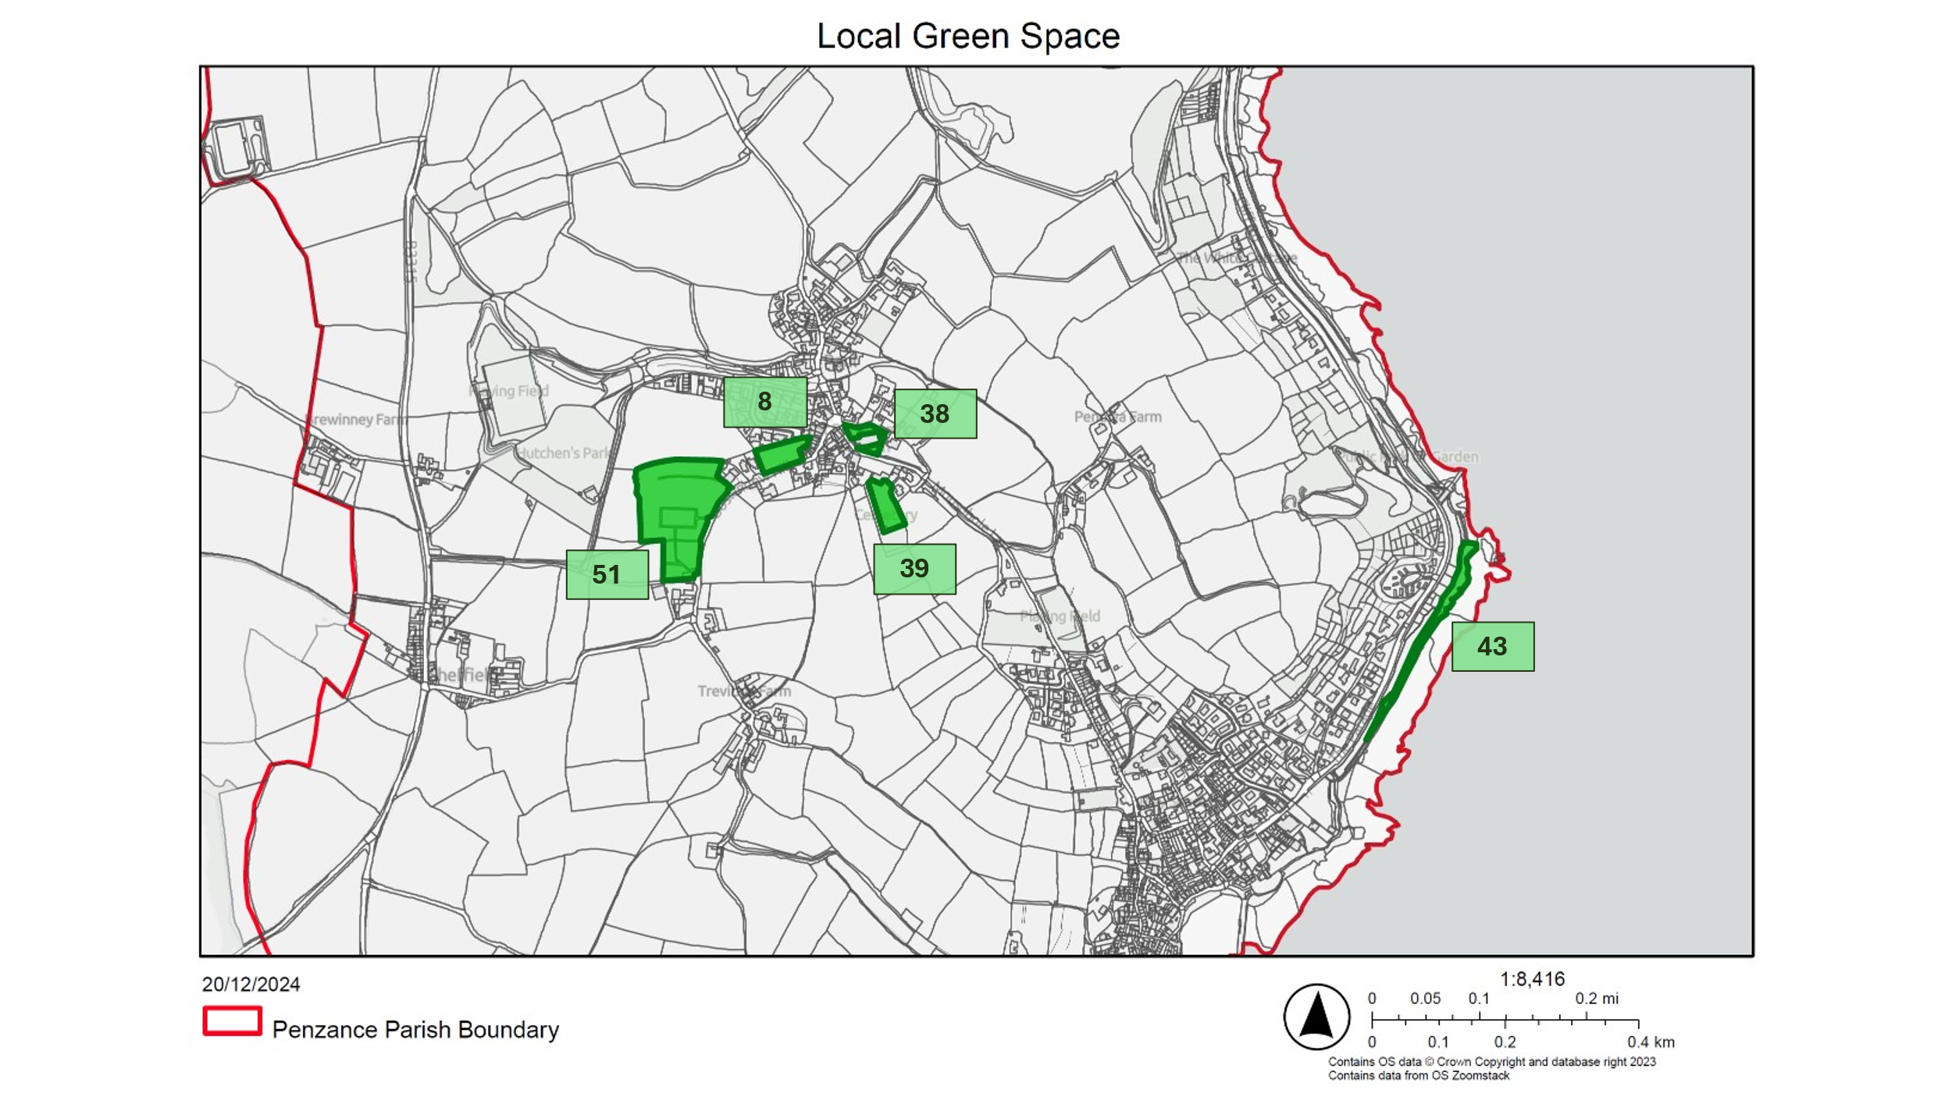
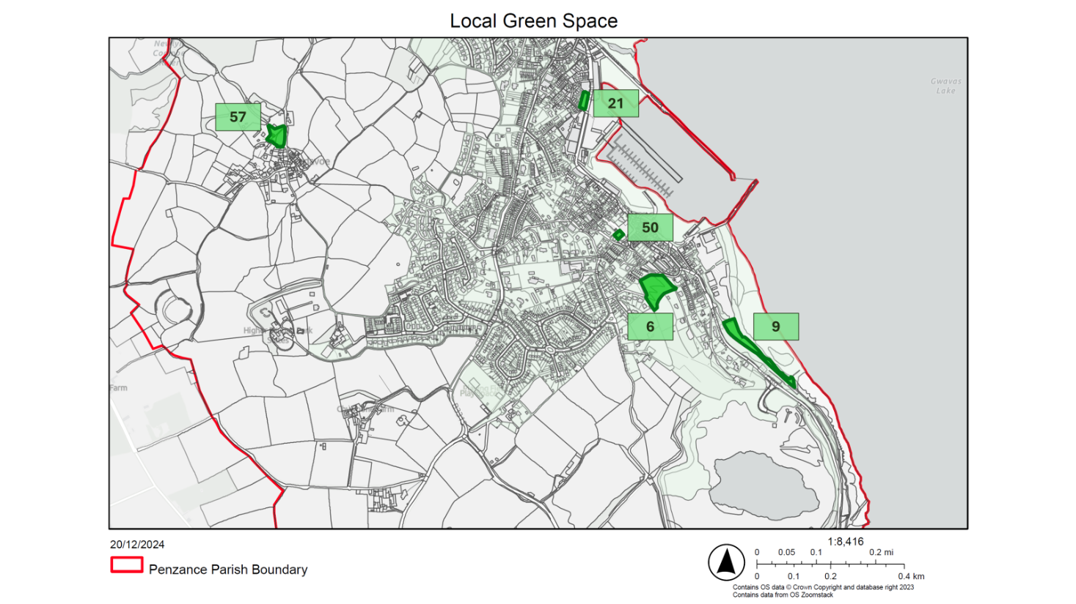
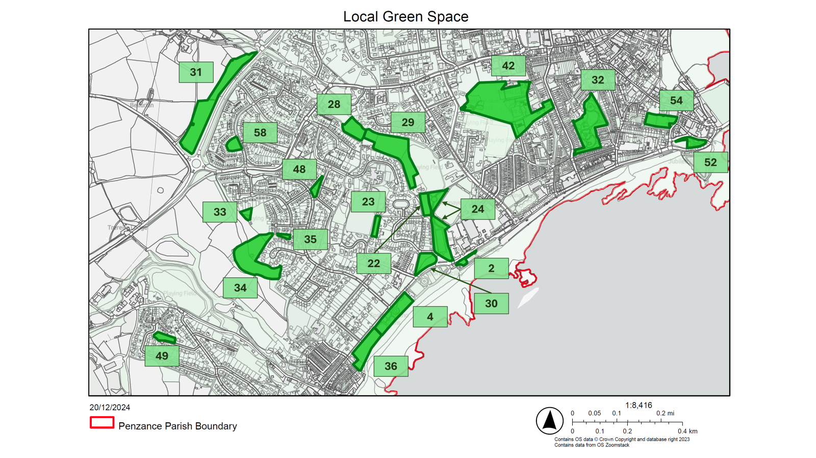
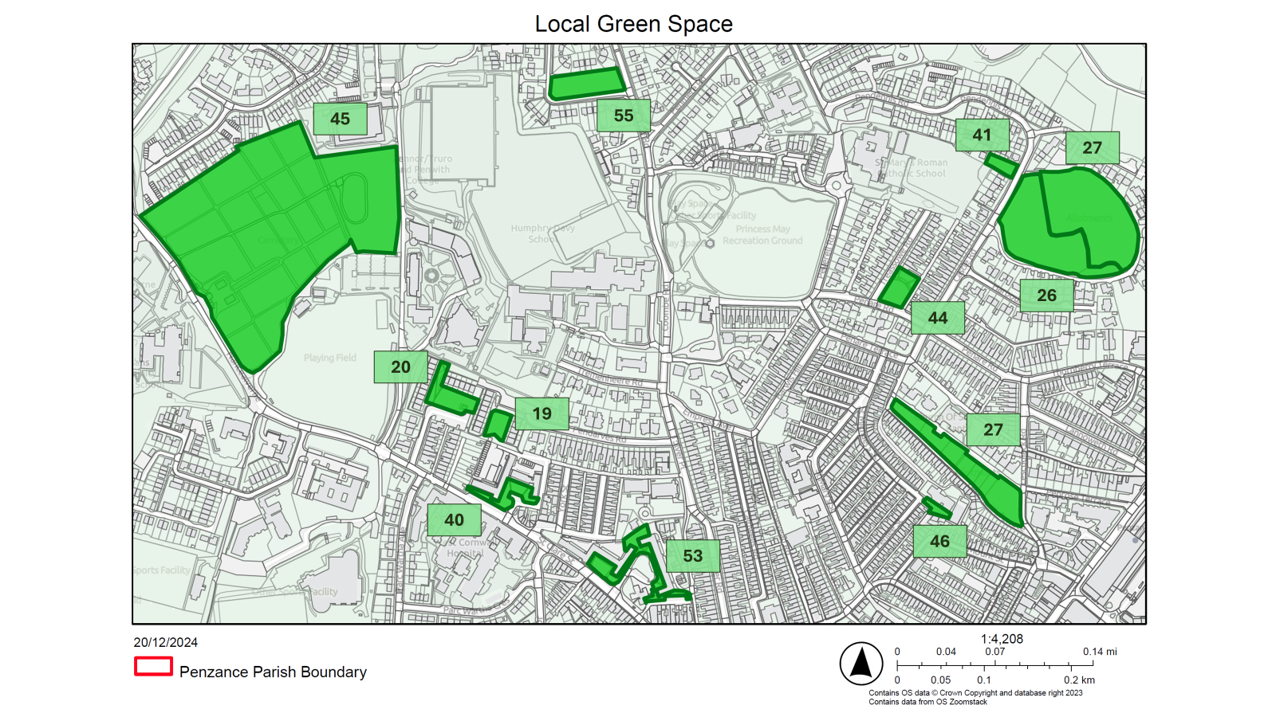
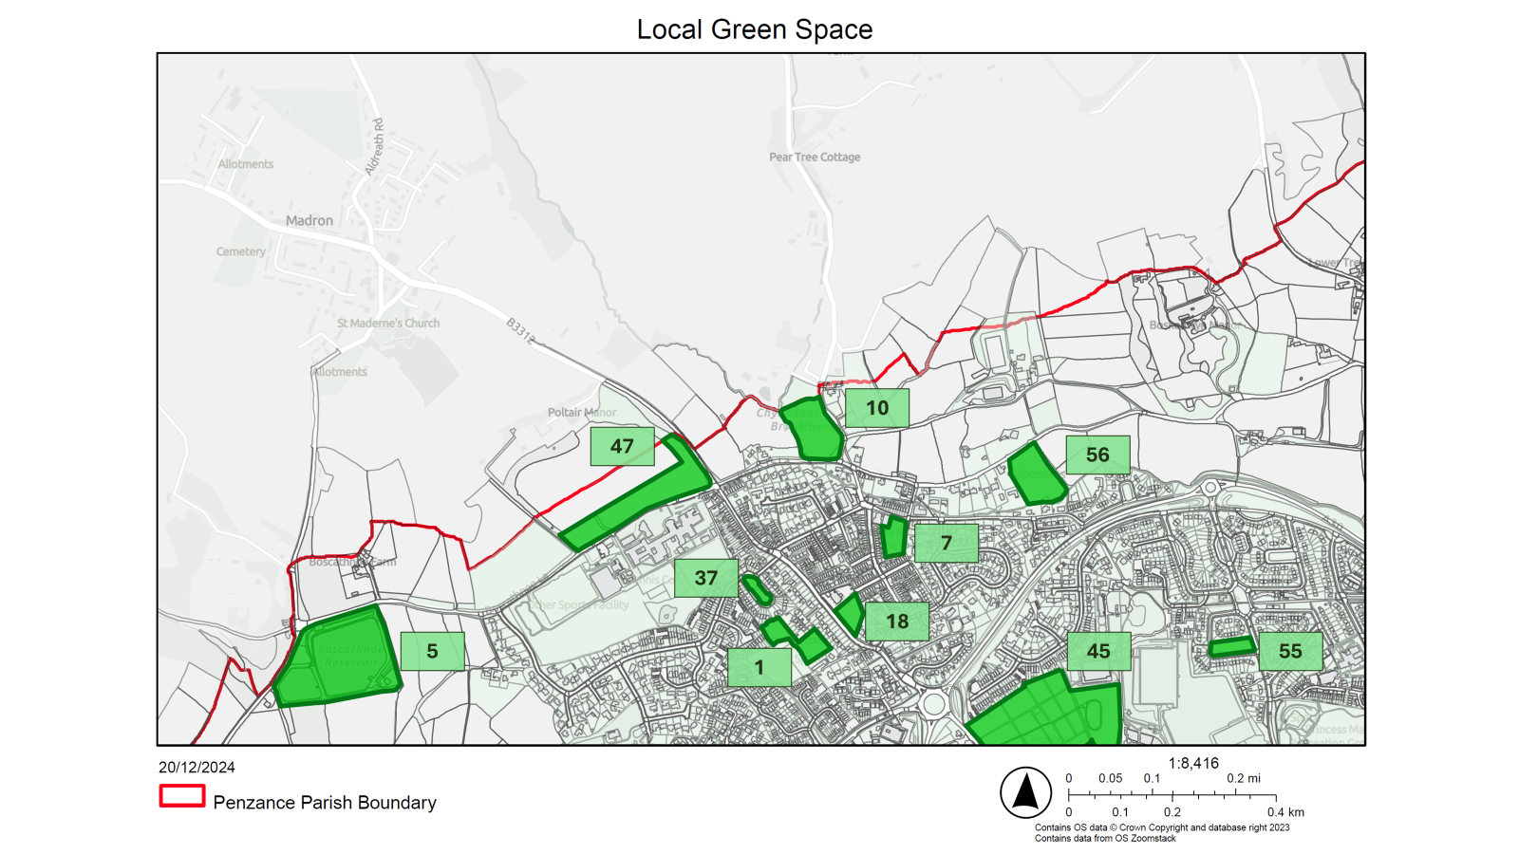

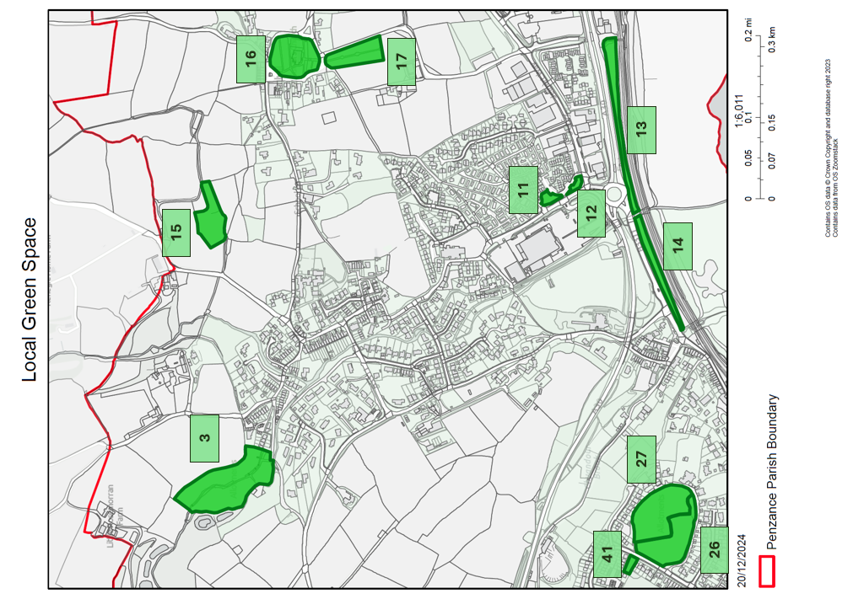

Open Space and Recreation Sites
Key to sites on maps

There are numerous other open spaces which do not qualify as LGS but which remain important. These have been protected, instead, through policy GI1a: Open space and Recreation. These spaces are listed below. Appendix 10 maps their specific location and defined area.

- Alverton Playing Field (Mount Misery)
- Alverton Primary School Playing Field
- Gulval School Playing Field
- Gwavas Playing Field
- Heamoor Primary School Main Playing Field
- Heamoor Primary School Second Playing Field
- Heamoor Recreation Field & Play Space
- Humphry Davy School Playing Field
- Hutchens Park Cricket Ground
- Love Lane (Rugby) Playing Field
- Love Lane Playing Fields
- Mennaye Field (Rugby Ground)
- Mount’s Bay Academy Playing Field 1
- Mount’s Bay Academy Playing Field 2
- Mousehole Primary School Playing Field
- Newlyn Coombe Playing Field and Greenspace
- Newlyn Primary School Playing Field
- Pensans Primary School Playing Field
- Penzance AFC Football Ground
- Princess May Recreation Ground
- Roscadghill Teen Space
- Rosevale Playing Field
- St Clare (Truro and Penwith College)
- St Clare Cricket Ground
- St Clare Sports Pitch
- St Mary’s Catholic Primary School Playing Field
- Trungle Moor Football Ground
- Wherrytown Play Area and Bowling Green

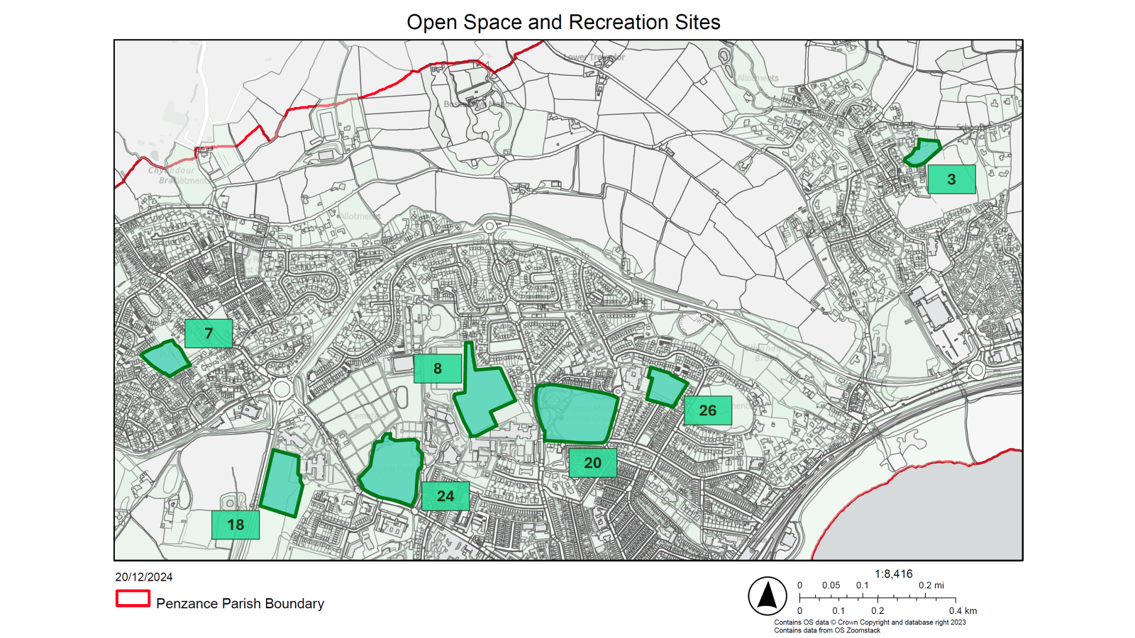
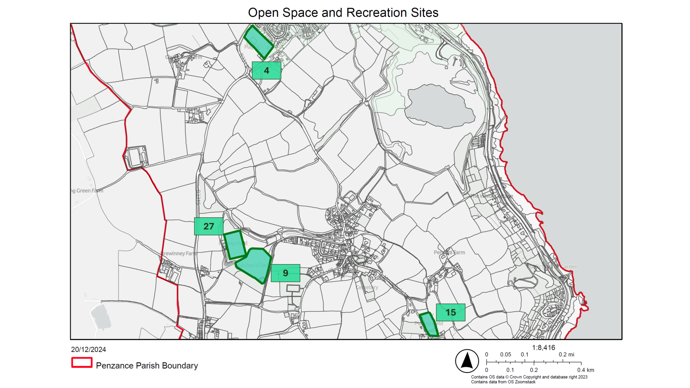

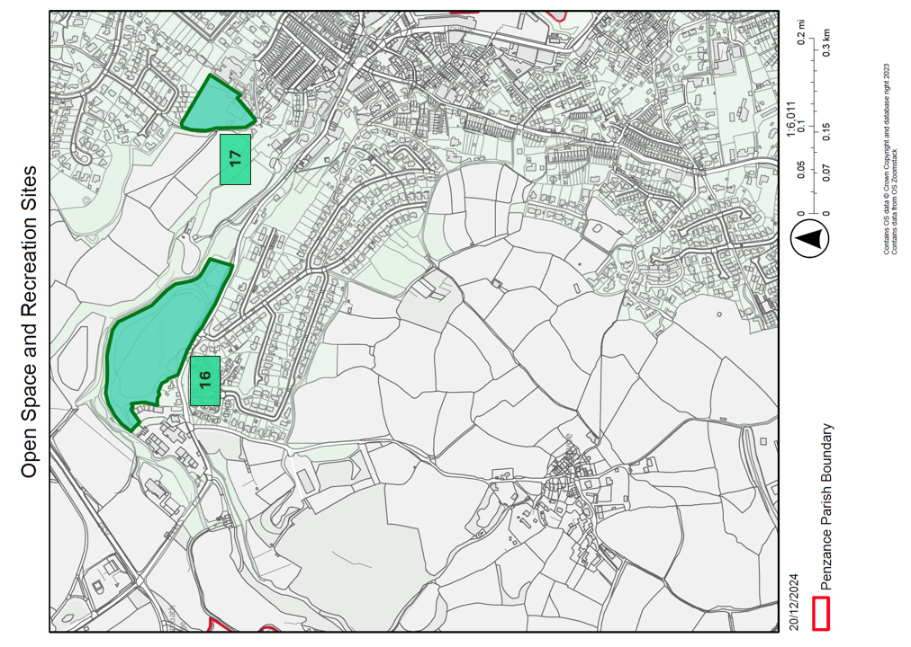
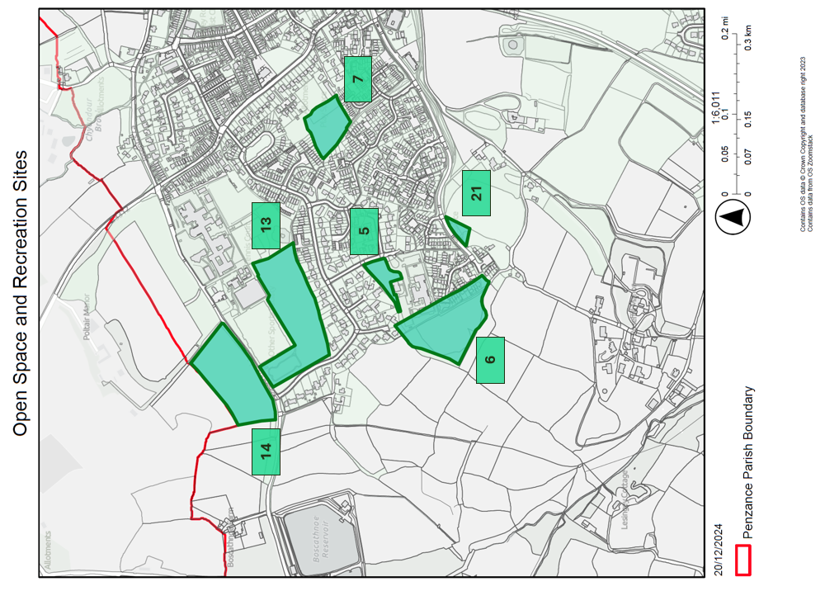
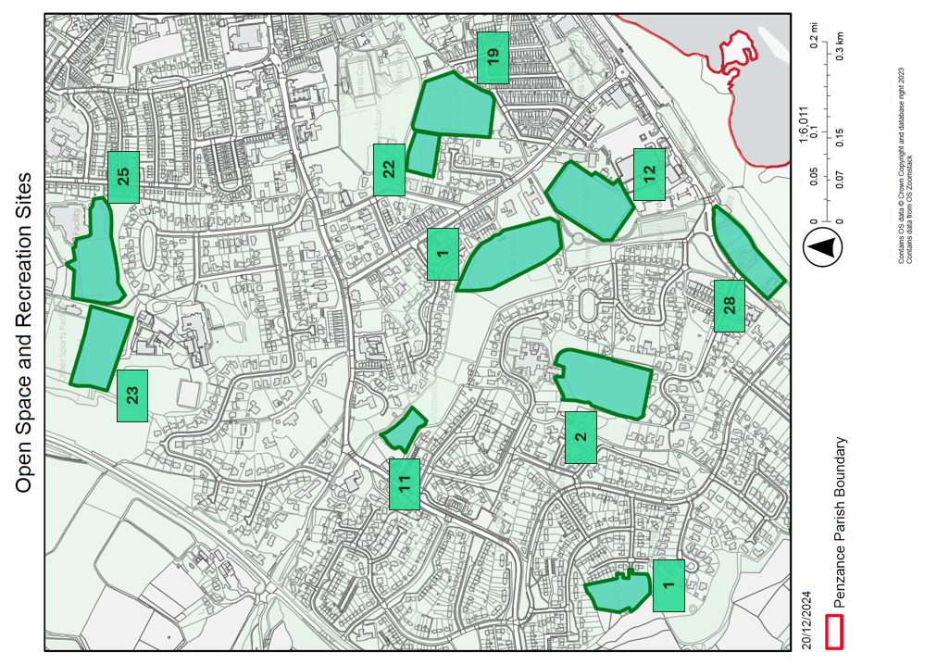

Green Infrastructure Spaces (used as one source of reference for identifying potential Local Green Spaces)
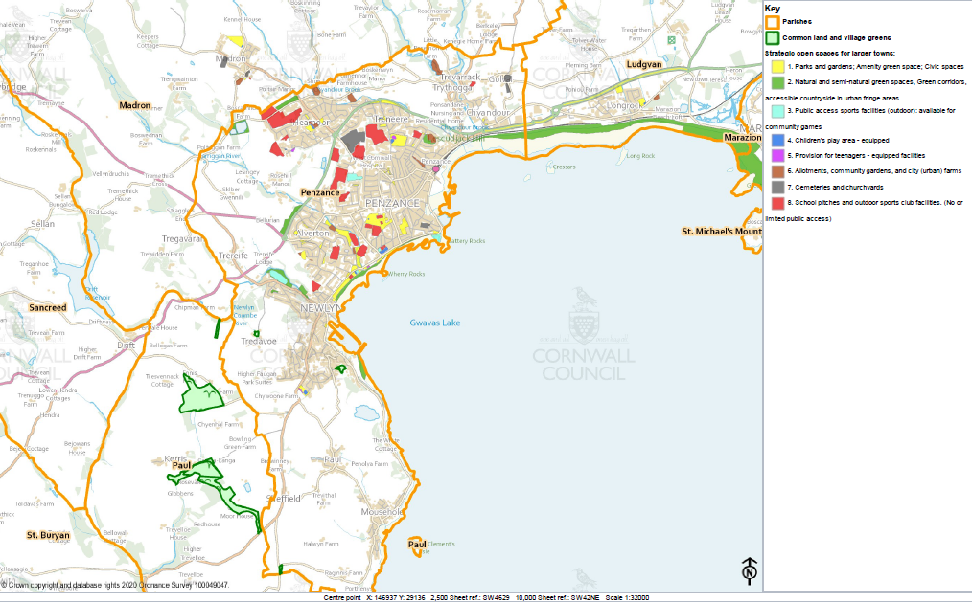
Source: Cornwall Council Interactive Mapping

As a result of their consideration at the Plan’s Examination.
Introduced following the Plan’s Examination.

