PENZANCE PARISH NEIGHBOURHOOD PLAN:
CONSULTATION QUESTIONNAIRE FOR MOUSEHOLE
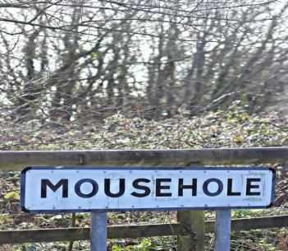

We want to know what you think about where you live so that your opinions can be reflected in the Neighbourhood Plan which can help to make positive changes for local communities.
Please fill in this questionnaire so we know what you think and if you’re interested in finding out more, come to a Drop - in at The Solomon Browne Hall on Tuesday 23 October from 3.30 to 7pm where you can talk to councillors and community volunteers from the Neighbourhood Plan team.
Please rate your answers to reflect your opinion. Unless you have no opinion, a comment will be really helpful to help draw together a view from the community.
TELL US WHAT YOU THINK |  | Rating | 1 | 2 | 3 | 4 | 5 | 1= agree strongly; 2= agree; 3= no opinion; 4= disagree; 5= disagree strongly
Mousehole is a separate community from Penzance with its own identity
If you ticked 1 or 2, please put down a few thoughts about what you think makes Mousehole different…..positives and negatives!
The “green parts” of our community…..open spaces, play spaces, footpaths and bridle ways are an important asset |  |  | 1 | 2 | 3 | 4 | 5 | Comments
a | It’s easy and safe to get to and use the existing green spaces, footpaths and bridle ways
b | The footpaths and bridleways are in good order and easy to use
The built environment and preserving Mousehole's heritage is important to me |  |  | 1 | 2 | 3 | 4 | 5
Having affordable housing in the village is important |  |  | 1 | 2 | 3 | 4 | 5
Second homes have an impact on the lives of me, my family and /or the community

Traffic and road safety is a major issue for people living in Mousehole |  |  | 1 | 2 | 3 | 4 | 5
a | We need measures to improve pedestrian and cyclist safety
b | We need to see traffic calming and better signage

LET US HAVE YOUR IDEAS - WHAT WOULD YOU CHANGE ABOUT MOUSEHOLE?
 | AREA FOR IMPROVEMENT | MY IDEAS
What do I do now?
- You can drop this questionnaire in the letterbox at St. Clement’s House 1, Duck Street, Mousehole
- You can bring it along to the Drop in Session from 3.30 – 7pm on 23 October at the Solomon Browne Memorial Hall
- You can complete the questionnaire on line. It’s on the Neighbourhood Plan website www.pznp.co.uk click on Survey to find it.

